Assignment – 5
A. Create an auto-response rule created for the fresh leads coming into the organization.
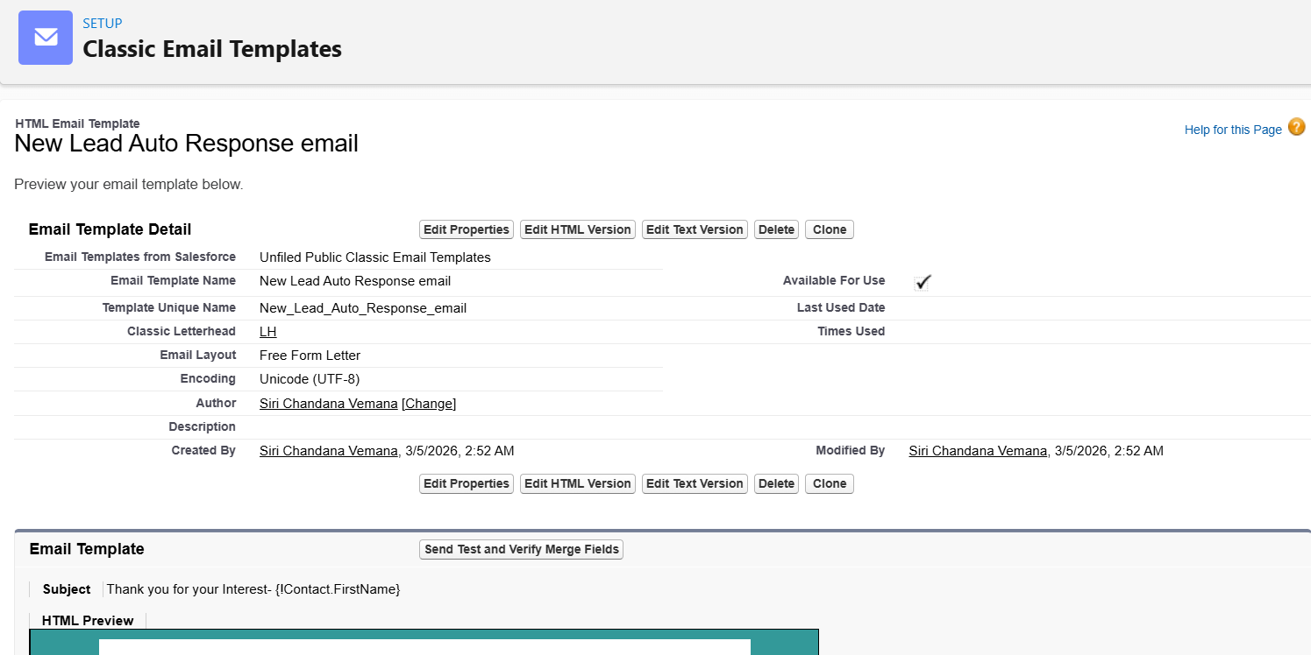
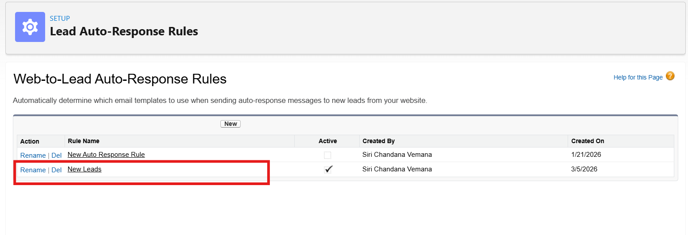
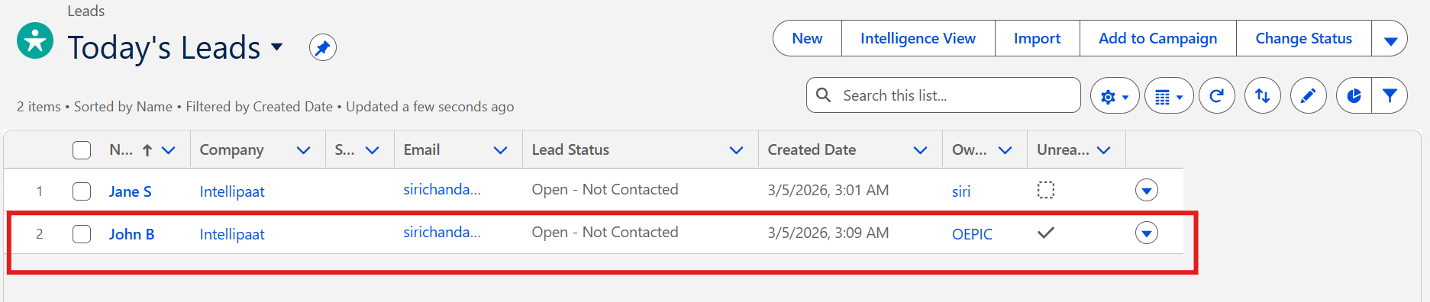
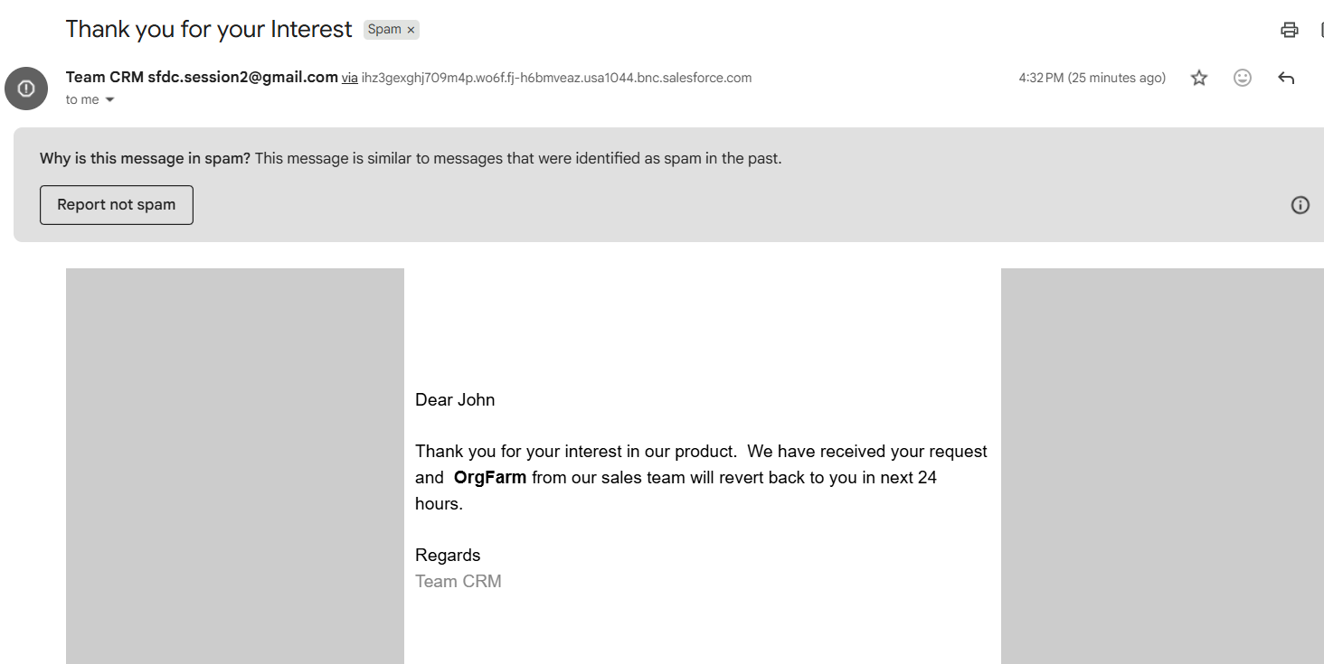
B. Apply lead scoring to the prospects (or potential customer) for optimizing the input leads to generate more revenue by following the customer who is likely to get converted into sales.
Created a Number Field and Formula Field for Lead Scoring as below:
Created a New Field in Leads Object as “Number of Courses”
And also created a formula field as “Lead Priority” with below formula
IF( Number_of_Courses__c > 3, "High" , "Low")
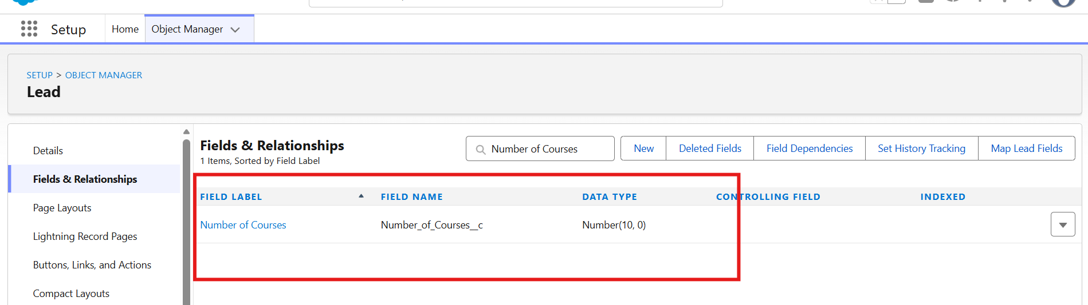
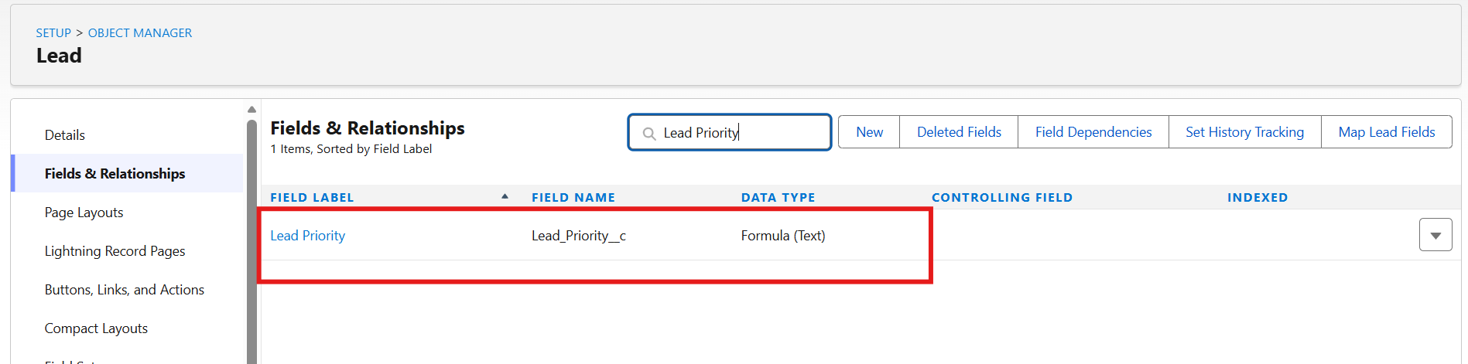
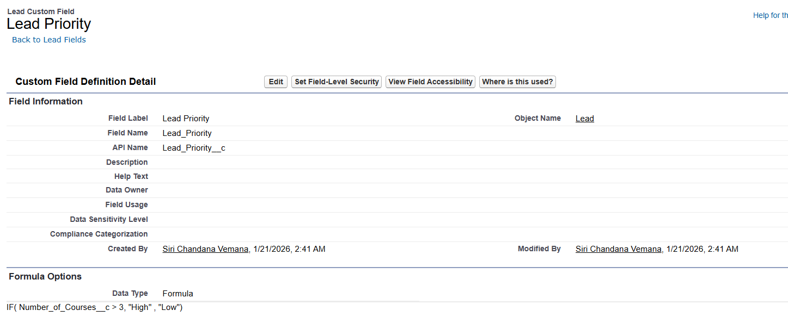

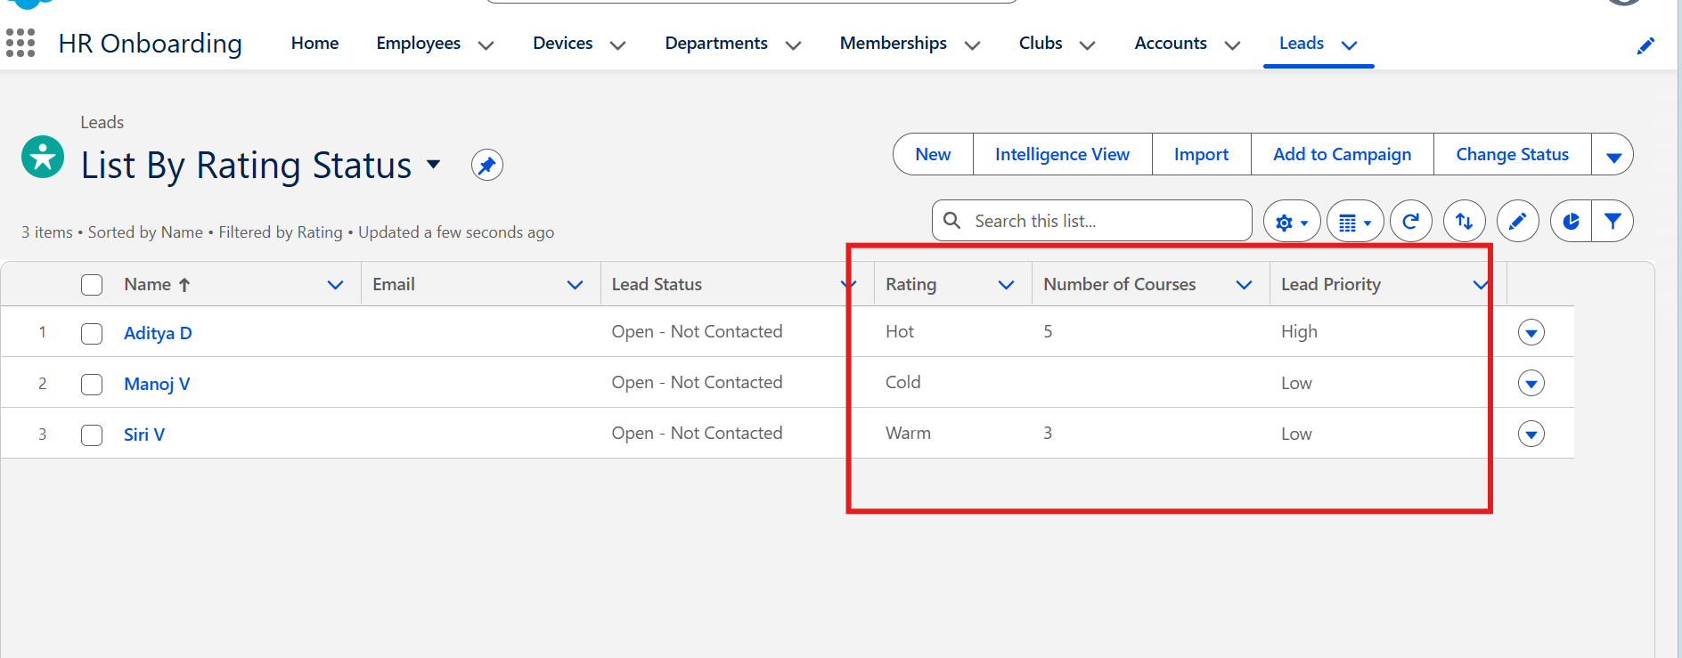

C. Create assignment rules for assigning leads of various categories to different sales executives according to the product type.
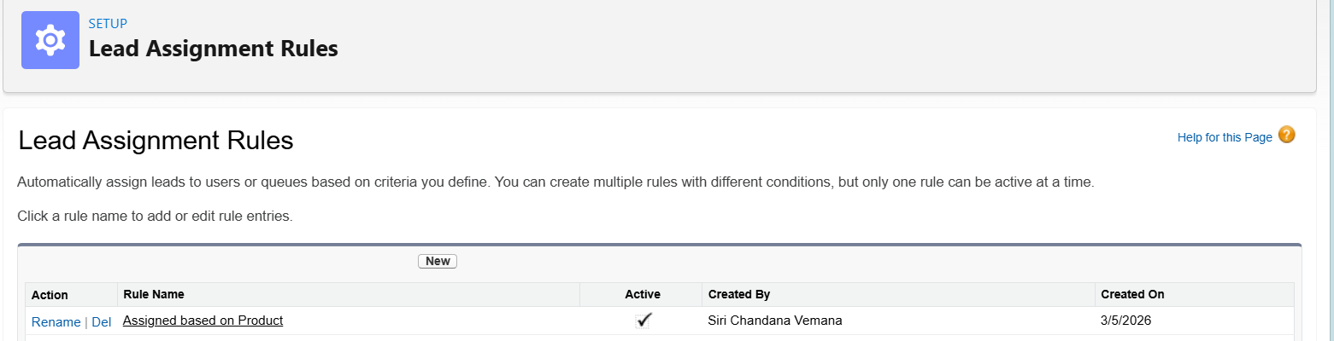
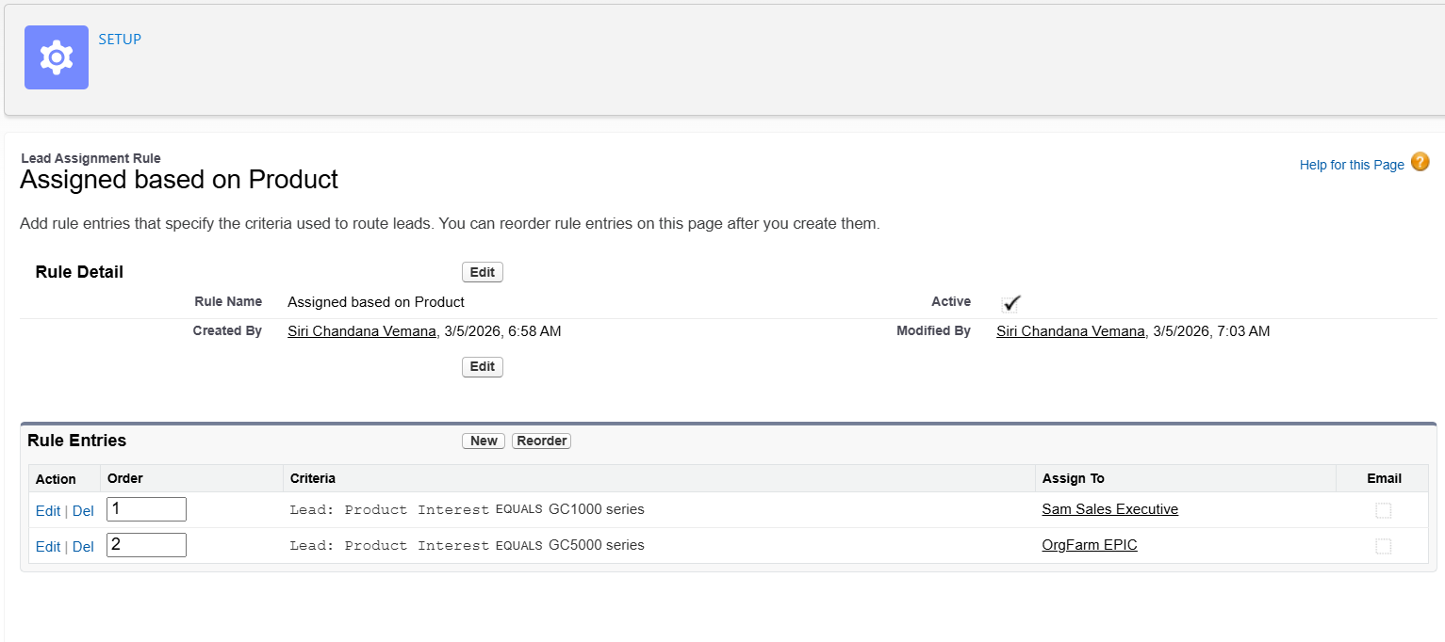
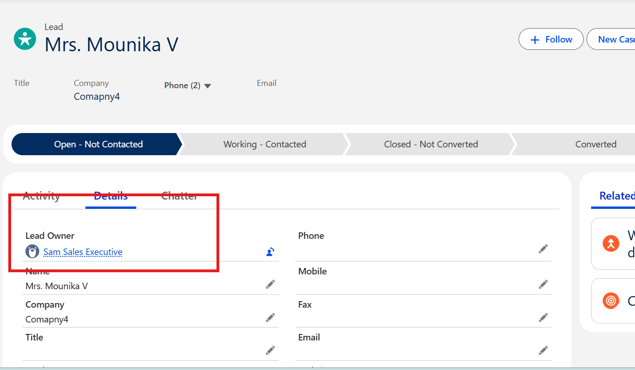
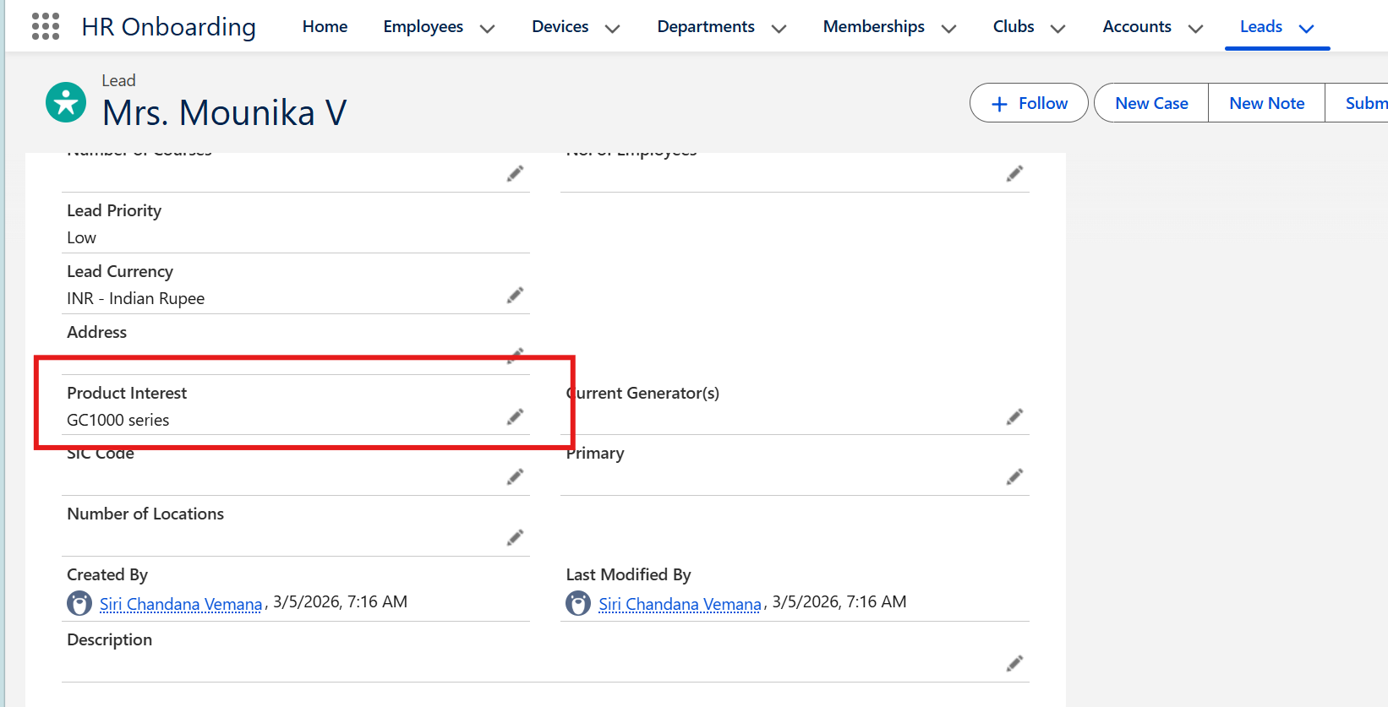

D. Add leads to Campaign in Salesforce through Campaign Member object.
